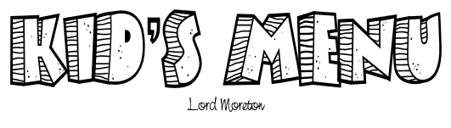

Main Meals
Cheese and Tomato Pizza served with Chips £5.95
Fish Fingers, Chips and Peas £5.95
Crispy Chicken served with Salad or Chips and Beans £5.95
Beef Burger in a bun with Chips £5.95
Sausage, Mash and Gravy £5.95

Drinks Included in the price
Orange Squash
Blackcurrant Squash

Dessert Included in the price
Vanilla Ice Cream
Strawberry Ice Cream
Chocolate Ice Cream

